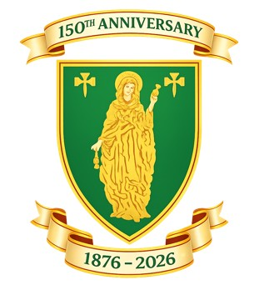
Merthyr RFC Youth (U18) Head Coach Job Description & Person Specification

Job Description
Purpose of Role:
To lead, manage, and develop the Merthyr RFC Under 18 squad, delivering a high-quality coaching programme that supports player development, performance, wellbeing, and progression into senior rugby.

Key Responsibilities
• Plan and deliver structured training sessions aligned to WRU principles.
• Develop technical, tactical, physical, and mental skills of players.
• Lead match preparation, selection, and tactical planning.
• Foster a positive, disciplined, and inclusive environment.
• Ensure safeguarding and player welfare at all times.
• Communicate effectively with players, parents, and club officials.

Person Specification
Experience
Essential:
• Experience coaching youth rugby (U16–U18 preferred).
• Delivering structured coaching sessions.
Desirable:
• Experience in club or representative rugby pathways.
• Leading a squad or coaching team.
Qualifications
Essential:
• WRU Level 2 Coaching Qualification (or working towards).
• Safeguarding certification.
• DBS clearance.
Desirable:
• WRU Level 3 Coaching Qualification.
• First Aid qualification.
Knowledge & Understanding
• Strong understanding of rugby union principles.
• Knowledge of player development and LTAD.
• Awareness of safeguarding responsibilities.
Personal Qualities
• Strong leadership and communication skills.
• Passion for developing young players.
• Positive, organised, and professional approach.
• Ability to motivate and inspire.

